### [**Holiday House Treat Box**](https://papercraftetc.blogspot.com/2015/12/holiday-house-treat-box.html)

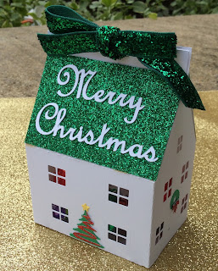

A Holiday House Treat Box

This treat box can holds six Hershey Kisses in one layer or twelve in two layers. I used regular cardstock for the house and glitter cardstock for the roof.

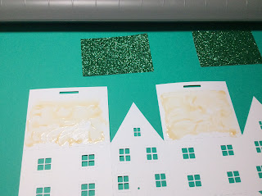

Glue as shown in the above picture

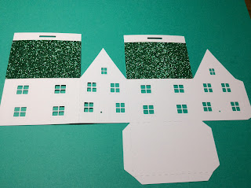

Attach the glitter cardstock

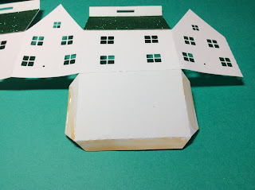

Crease the edges and glue the tabs.

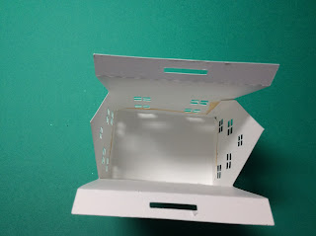

Make sure all of the angles are perpendicular and the bottom of the box is flat.

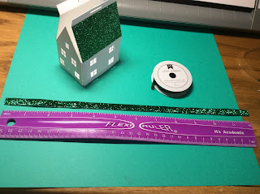

Cut a 12 inch piece of ribbon for the tie.

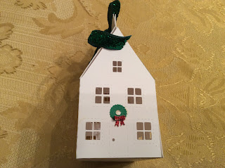

Glue on the wreath and bow.

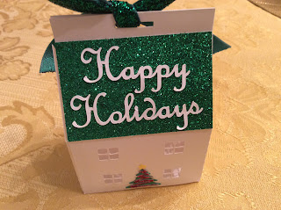

Glue on the tree and holiday greetings.

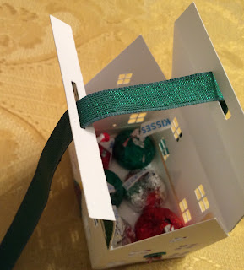

Box with 6 Hershey Kisses.

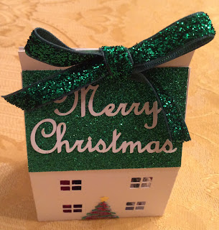

Tie a bow to complete the house.

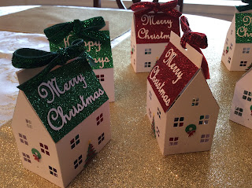

Merry Christmas and Happy Holidays!